

LEARNERS WITH SEVERE TO PROFOUND INTELLECTUAL DISABILITY
LESSON PLAN
TERM 3 & 4

CONTENT
- Lesson plan theme and topics……………………………………………………………………………….….……. Pg 2
- Assessment methods and descriptors……………………………………………………………………….………. Pg 3
- Carer’s role in the facilitation of the lesson plan theme and topic………………………………………….……...Pg 4
- General accommodations……………………………………………………………………………………….……..Pg 10
- Addendums……………………………………………………………………………………………………….……..Pg 12

Theme: My environment Topic: My family members (Term 3) / My class & friends (Term 4) |  |  | Start date: July 2024 Date completed: December 2024
Note: Be mindful that learners come from different homes and different combinations of family members within each household. All these homes and households should be acknowledged, appreciated, and given the same value and respect during the lesson. The language, both verbal and nonverbal used when discussing these different homes and their families should be handled with positivity, respect, and appreciation.  The LSPID team members, together with the special care centre staff, is responsible for adapting lesson plan activities, LTSM and other resources to suit the cultural environment of the area the special care centre is located in.  Throughout the day, observe the learner's reaction to the different activities and try to find time to record learner’s reactions using an informal observation sheet.  Your centres’ daily programme may not follow the same sequential progression as this lesson plan. There is no need to follow this plan as is. Use the lesson content and follow the daily programme you use in your centre/ school.  The therapists and teachers among the outreach team members will guide and support the caregivers / teachers in planning and implementing the lesson activities. This includes assessing learners and guiding caregivers and teachers on relevant accommodation of learners, should some learners’ impairments impede their participation in the learning programme. |  |  | Resources:  Learning and teaching support materials that are mentioned in the lesson plan include, but are not limited, to the ones listed below:  Recyclable material  Cereal boxes, bottle caps, match boxes, toilet rolls, newspaper, magazines, sticks, paper towel rolls.  Art material  Wool, string, buttons, pipe cleaners, play dough, paint, glue, wax crayons, ice cream sticks, pieces of off-cut material, paper plates, chalk, tape.  Photos or DVDs (DVDs not compulsory)  Media of different family members, household pets and the role of different family members within the home. The photo representations of different family members should include different age ranges and be culturally sensitive to the learners’ frame of reference.  Special care centres may encourage learners to bring items from their home, if possible. The items could be displayed in the theme area (if space allows for a theme area) or used during discussion time
Assessment
Method of assessment: Informal assessments, observations & carer interviews
Assessment tool: Checklists, observation sheets & lesson plan assessments recording tools (LARTS)
PLEASE NOTE: Descriptors below serve as the learner participation requirements during all parts of the daily programme, e.g., fine motor, morning ring.
Functioning groups | Awareness | Transitional |  | Interactive
Language (LC) | Learner outcomes: | Learner outcomes: |  | Learner outcomes:
Rec | - React (or react intermittingly) to familiar people and events. | - Respond consistently to familiar people and events. |  | - Initiate interactions with familiar people.  - Actively explore events for more extended periods.
Expr
Pre lit
Life-Skills (LS) | Learner outcomes: | Learner outcomes: |  | Learner outcomes:
Selfcare:  Toileting & Feeding & Personal Care | - Show awareness (or momentary awareness) with regards to themselves & familiar people during selfcare activities. | - Show consistent responses during the same selfcare activity.  - Explore items used during selfcare activities. | - Match/ identify/ name items used during selfcare activities.  - Follow 1 step (or more) instructions.
Physical Education (PE): Balance & Coordination | - Show momentary awareness during experiences that involves moving the body through space. | - Show consistent responses to specific activities that require balance and coordination.  - Remember learned responses within the same day. | - Copy and repeat simple single actions.  - Perform and increase range of actions related to balance and coordination.
Creative Arts (CA):  Visual Arts | - Show momentary awareness to familiar people, experiences or objects. | - Shared exploration of textured art materials  - Explores materials with increasing complexity. | - Make marks intentionally on surfaces and repeat the action for a similar effect.  - Apply familiar technics to create an art product.
Mathematics (Maths) | Learner outcomes: | Learner outcomes: | Learner outcomes:
Space and Shape | - Show momentary awareness (or begin to show interest) to 3D objects. | - Show consistent preference to objects they are exposed to daily.  - Shared exploration of objects colour, shape, orientation, and quantity. | - Correct usage of basic, 3D objects.  - Match/ identify/ name basic 3D objects.  - Sort basic 3D objects into different categories.
Measurement | - Show momentary awareness (or begin to show interest) to 3D objects. | - Respond consistently to familiar events within the daily routine.  - Seek attention to request a regular event in a daily routine. | - Anticipate, follow, and join in familiar activities.  - Answer using words or gestures when asked about passed events, the learner was involved in.
CARER’S ROLE IN THE FACILITATION OF THE LESSON PLAN THEME AND TOPICS

Daily  Program | Awareness activities | Transitional activities | Interactive activities
Discussion | RESOURCES NEEDED:  - Baby doll and/ or toy cat and dog  - Handmade puppets of different family members. Made from recyclable items  (See Addendum for examples) | RESOURCES NEEDED:  - LSPID team to supply SCC with laminated photo images of people from different age and racial groups – specific to the culture of the learners’ environment. (See Addendum for examples)  - If possible, guardians can be asked to send printed photos, or via cell phone message to the carer to be used during discussion. This is however not compulsory.
Discussion | - Carer mentions learner’s name, while touching him/ her on their shoulder to attain some level of awareness.  - If familiar with the learner’s family, name the learner’s guardian/ sibling’s names and tell the learner their family loves him/ her very much.  - Repeat the same discussion throughout the day, e.g during feeding & nappy changing. | Term 3: Me and my family  - Carer announces the discussion topic: “Families”, including who makes part of a family.  - Laminated photo images of different family members are introduced to the group.  - Distinguishing features of different members are highlighted, e.g., a mother/ grandmother cooks and washes our clothes; a sister might have braids; grandparents may have grey/ white hair; babies are small & cry when upset.  - Encourage learners who are willing to name their own family members and how they participate in the household.  Term 4: My class and my friends  - Follow the same discussion guidelines as Term 1 & 2’s topic of “Me and my home”, when introducing the topic of “My class”. Focus on the different areas relevant to the learners’ daily routines, e.g., snack time area, morning ring area, toileting area as well as the inside and outside play areas. Display objects that are typically found in the different areas, e.g., spoon, toilet paper, ball, table, chair, blocks.  - Follow the same discussion guidelines as Term 3’s topic of “Me and my family”, when introducing the topic of “My friends”. Focus on identifying the different learners within the class.
Gross motor | RESOURCES NEEDED:  - Speaker (not compulsory). | RESOURCES NEEDED:  - Open area to accommodate for gross motor play  - Masking tape/ Chalk/ Hoola-hoops / Recycled paper towel or foil rolls/ Pool noodles
Gross motor | The wheels on the bus  - Carer positions herself in front of the learner.  - Activity is done on a one-on-one basis.  - The carer sings the song “the wheels on the bus” (or play the song on speaker).  - The following actions are facilitated by means of hand-over-hand support (Do not force the actions, as this could cause injury):  - The wheels go round: take learners forearms; gently facilitate a circular motion.  - The wipers go “swish”: take the learners forearms and gently move them left to right.  - The horn goes “beep”: Take one of the learner’s hands and gently press down on tray table (or surface), as though horn is being pressed.  - The babies go “wah”: Take both learner’s hands and gently place their hands over their eyes (pretending to wipe their tears). | Musical chairs  - This activity is best performed with 2 to 3 learners per carer.  - Place enough chairs for the number of learners participating in the activity.  - The carer starts playing or singing a song, preferably familiar to the class.  - Demonstrate how to walk or run around the chairs – sit on a chair once the music stops.  - Learners should be supported physically and verbally, leading them around the chairs and indicating when to sit, stand and move.  - Learners who have floor mobility, should be encouraged to crawl around the chairs.  - Should a learner have no mobility, he/ she should be pushed in their buggy or wheelchair.  - Do not remove any chairs for the duration of the game. | Jumping in the house  - Use pool noodles, sticks, masking tape or chalk on a cement surface or ground outside. Use last mentioned to form a large square on the ground surface. Add a triangle to the square, to form the shape of a simple house.  - The carer makes the learners aware of the pretend house. They will be playing in the house.  - The carer first demonstrates how to perform simple, single actions to get “into” the house. Whereafter learners are physically supported to “step” or “jump” into the house.  - “Jump in” “Jump out”  - “Step in” “Step out”  - Learners should also be supported to walk along the lines of the house.  - Practice identifying your own name, as well as identifying the friend in front & behind you!  Use different textures to form the house’s outlines, enhancing the sensory experience.
Table activities / fine motor | RESOURCES NEEDED:  - Paper plate face masks and/ or handmade puppets (use masks and puppets made by learners in the Interactive groups). | RESOURCES NEEDED:  - Various laminated play-dough activity sheets, supplied by LSPID teams.  - Play dough (See Addendum for recipe) | RESOURCES NEEDED:  - Recyclable material, e.g toilet rolls, ice cream sticks, foil, bottle caps, paper cups, empty cooldrink bottles.  - Craft items, e.g glue, cut-off material pieces, string/ wool, crayons/ paint, scissors.
Table activities / fine motor | Sensory exposure: paper plate masks/ puppets:  - Carer mentions learner’s name, while touching him/ her on their shoulder to attain some level of awareness.  - Should the learner be able to see, the carer holds mask/ puppet near the learner’s face.  - Take the learner’s hand and name each part of the puppet as you move the learner’s hand, e.g “This is the head”; “Let’s feel the hair”.  - Explain what the learner is experiencing with regards to different textures, e.g “The hair is soft, it feels nice”, “The nose is sharp, ouch!”.  (Should the learner’s hands not be able to fully open to explore, the carer may use the back of the learner’s hand or forearm.) | Play dough activity:  - Attempt activity in small groups (2 – 4 learners).  - Place laminated sheet in front of learner.  - Name and discuss the item printed on the sheet; e.g “This is a baby bottle, a baby drinks milk from the bottle” or “This is a tie, some dads and grandfathers wear ties” or “This is a pot, a mother/ grandmother or sister makes food in the pot”.  - Demonstrate breaking off pieces of play dough/ rolling snakes/ rolling balls.  - Show how to place play dough pieces on the edges of the printed “item”.  - Provide hand-over-hand support throughout. | Handmade puppets:  - Attempt activity in small groups (3 – 4 learners).  - Carer can show learners a picture of the puppets they are to make, or alternatively the carer makes a puppet beforehand. This gives learners a concrete idea of the task.  - Learners to choose which family member they want to make a puppet of.  - Carer gives guidance on the first step of making the puppet and continue with one (or maximum 2) instructions at a time.  - Making the puppet can be spread over a week, completing a few steps per day  - Carer provides verbal and physical support as needed.
Structured  Play | RESOURCES NEEDED:  - Paper plate face masks of different family members (made by Interactive groups). | RESOURCES NEEDED:  - Familiar objects used by different family members in everyday situations, e.g baby bottle, dad/ brother/ grandfather’s cap/ hat or traditional head piece, beaded necklace, brush/ comb, dish, and spoon. | RESOURCES NEEDED:  - Handmade hand puppets and/ or face masks (made during tabletop activities).  - Specific clothing items or accessories related to different family members (not compulsory).
Structured  Play | Paper plate peek-a-boo  - This activity is performed on a one-on-one basis.  - The carer repeats the learner’s name a few times and touches their shoulder or arm – in attempt to create some level of awareness or brief eye contact.  - The carer then holds the paper plate in front of her face (or the learner’s face).  - The carer poses the question “Where is (insert child’s name)??!!”  - Quickly remove the paper plate and excitedly call “There she/ he is!!” while touching the learner’s shoulder/ arm.  - Repeat the same action a few times. | Exploration of items related to family members  - Initiate exploration of items in a small group of 1 – 3 learners.  - Place a familiar object in front of the learner.  - Provide hand-over-hand support to enable learner to touch and experience the object’s sensory aspects.  - Demonstrate the correct usage of the object, e.g pretend eating with the spoon, or placing the necklace around the learner’s neck.  - Provide hand-over-hand support for the learner to elicit a sound using the object, e.g bang the spoon on the table or shake the beaded necklace. | Fantasy play  - Present group with various clothing items; or  - Learners collect the puppets/ face masks they made during Tabletop activities.  - The carer initiates fantasy play amongst a smaller group, by pretending to be a family member, e.g baby/ mother/ dog/ grandfather. Mimic the family member’s physical stature and voice/ sound. Move on to another smaller group and initiate play amongst them in the same manner.  - Support the learners during fantasy play by “giving them certain instructions regarding the role of the family member” or asking them applicable questions, e.g “did you make your children food?”
Music & movement | - “Daddy finger, daddy finger where are you?  Here I am, here I am! How do you do”  (Take learners thumb in your hand to represent “daddy finger”. Wiggle the learner’s thumb while singing “daddy finger”).  Continue with mommy finger (pointer), brother finger (middle), sister finger (ring) and baby finger (little finger). | - “Daddy finger, daddy finger where are you?  Here I am, here I am! How do you do?!”  (Encourage or support learners to stick out their thumb in the air to represent “daddy finger”).  Continue with mommy finger (pointer), brother  finger (middle), sister finger (ring) and baby  finger (little finger).  2) “My family has got 5 people  1, 2, 3, 4 5!”  (Support learner to show 5 fingers)  “We like to walk together”  (Encourage walking action)  “1, 2, 3, 4, 5!”  “We like to sit together”  (Encourage sitting action)  “1, 2, 3, 4, 5!  We like to jump together”  (Encourage jumping)  “1, 2, 3, 4, 5!!! | - “My family has got 5 people  1, 2, 3, 4 5!”  (Support learner to show 5 fingers)  “We like to walk together”  (Encourage walking action)  “1, 2, 3, 4, 5!”  “We like to sit together”  (Encourage sitting action)  “1, 2, 3, 4, 5!”  “We like to jump together”  (Encourage jumping)  “1, 2, 3, 4, 5!!!”  - “I love mommy, she loves me!  We love daddy, yes sirree  He loves us, and so you see  We are a happy family!”  “I love sister, she loves me!  We love brother, yes sirree  He loves us, and so you see  We are a happy family!”
Story time | RESOURCES NEEDED:  - Clothing items, accessories or props relevant to different family members.  - 2-Dimensional pictures (photo representations, not pictures) of different family members – variety of ages and culture specific to learners.
Story time | - Tell a short and simple story about the learner and their family members.  - Individualize the story to include the learner’s name and the name of their family members.  - Include various props (hand puppets and/or a doll). Attempt continuous eye contact, touch, and slow/ clear speech throughout the storytelling. | - Tell a simple relevant story about the learner, their family members and the roles of the members within the family.  - Include various 3D props (clothing and accessories, hand puppets and/or a doll) as well as 2D story cards (photo representations, not pictures).  - Encourage the learners to perform the actions and sounds used in the story.  - Facilitate the actions. Then withdraw hands-on support to allow the learner to explore the movements and actions.  - Assist the learner to point to the mentioned picture or prop. | - Tell a simple relevant story about the learner, their family members, and the roles of the members within the family.  - Include various 3D props (clothing and accessories, hand puppets and/or a doll) as well as 2D story cards (photo representations, not pictures).  - Encourage the learners to perform the actions and sounds used in the story.  - Assist the learner to point to the mentioned picture or prop.  - Prompt the learners to answer simple questions about the story. Assist learners to match props, actions and/or sounds with relevant pictures in the book or on the story cards.
General Accommodations

Physical limitations |  | Learners who are positioned in a wheelchair/ buggy should be included in as many parts of the activities as possible. Attempt to include the learner by bringing the activity to the learner in his/ her chair, e.g., on their tray table or by pushing the learner to an area where he/ she can access needed items.  Learners with limited hand function should be supported with hand-over-hand support and/ or by adapting the activity in such a way that participation by means of eye contact, gestures or sounds.
Communication difficulties |  | Learners have limited speech or who are non-verbal, should be accommodated by means of basic augmentative and alternative communication, namely: photo cards, simple gestures, facial expressions or vocalizations.
Sensory impairments |  | Learners who experience hearing impairments should be positioned in such a way that they are able to observe the carers lips, facial expressions and gestures. Carers should speak slowly and clearly. If the learner has a side that has better hearing abilities, the learner should be positioned with his better side nearest to the carer.  Learners who experience visual impairments should be positioned near the front of the group. The carer should speak slowly and clearly. Learners should be exposed to alternative sensory strategies, e.g. a tactile daily programme schedule, constant verbal guidance and reassurance, contrasting backgrounds for table-top activities.
Learner Specific Accommodations
Daily Programme | Learners’ Name |  | Accommodation | Teacher remarks
Arrival

Morning Ring

Discussion

ADL’S

Additional:

Reflections
Caregiver/Teacher’s comments/reflections:

Expanded opportunities:

Centre Manager’s reflections:

SPID team input: monitoring and support:

ADDENDUM: ACTIVITY EXAMPLES

Hand puppets | 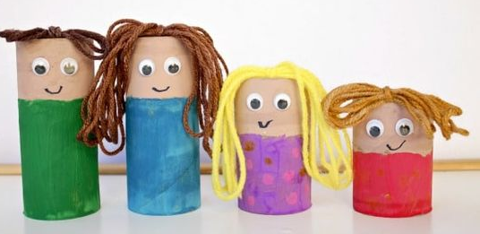 | 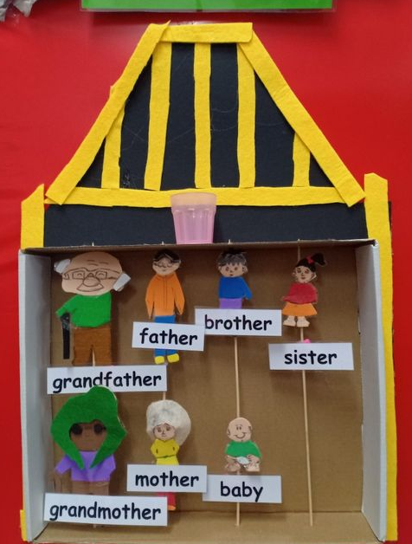 | 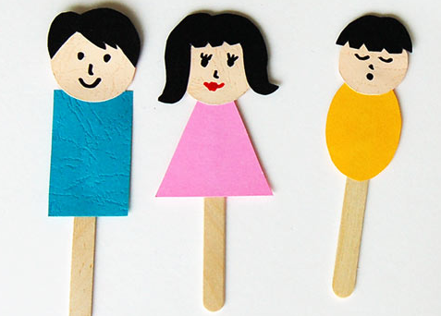
Face masks | 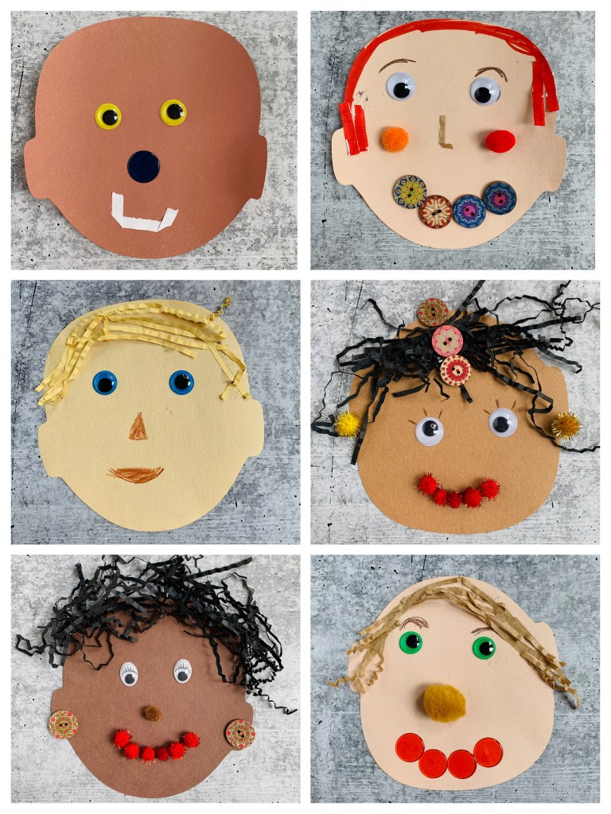
Tape activities (Step-ladder) | 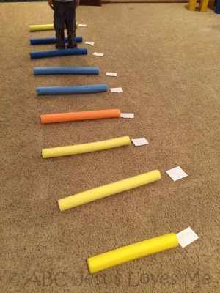 | The wheels on the bus lyrics  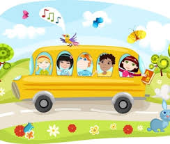 | The wheels on the bus go round and round  Round and round, round and round  The wheels on the bus go round and round  All day long  The wipers on the bus go swish, swish, swish  Swish, swish, swish, swish, swish, swish  The wipers on the bus go swish, swish, swish  All day long  The horn on the bus goes beep, beep, beep  Beep, beep, beep, beep, beep, beep  The horn on the bus goes beep, beep, beep  All day long  The babies on the bus go wah, wah, wah  Wah, wah, wah, wah, wah, wah  The babies on the bus go wah, wah, wah  All day long
Play dough recipe  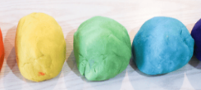 | 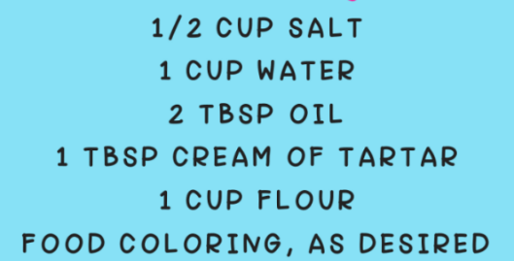  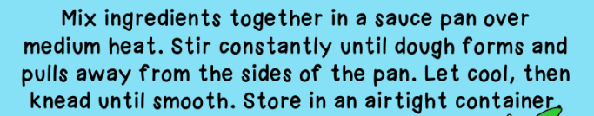

Play dough activity:
Roll play dough “sausages” and place along the border of baby’s bottle

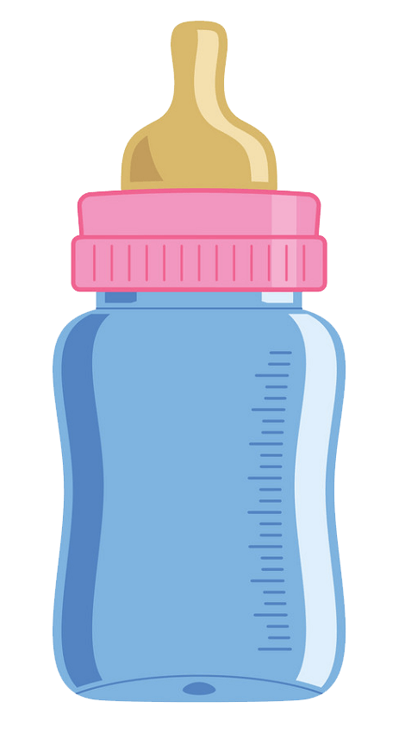

Example of placed “sausages”

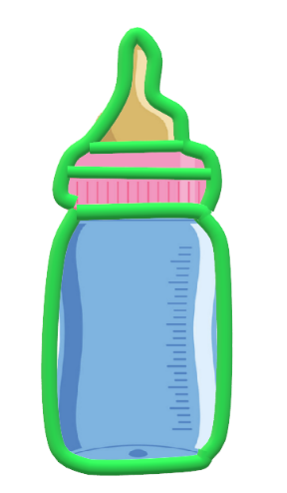

Play dough activity:
Roll play dough balls and fill the pot with “food”

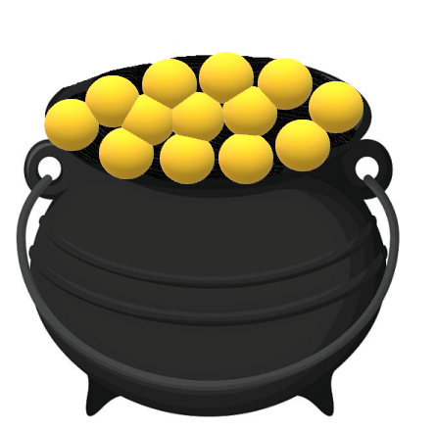

Play dough activity:
Roll play dough “sausages” for dad/ uncle’s tie

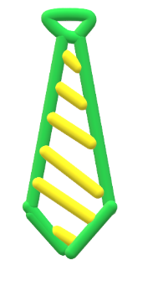
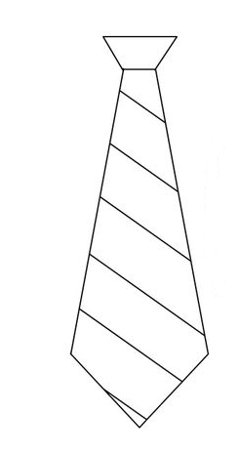

Example of placed “sausages”

QUALITY ASSURED AND APPROVED BY:
MR EJ NGCOBO
DIRECTOR: INCLUSIVE EDUCATION
SIGNATURE:

DATE:

